**Lesson15 Azure Soft Delete**

**Notes:-**

**1-with soft delete it allow you to recover your blobs , (its make your blob hidden for period of times then after it will make deleted , and this allow you to undelete while you are on this period)**

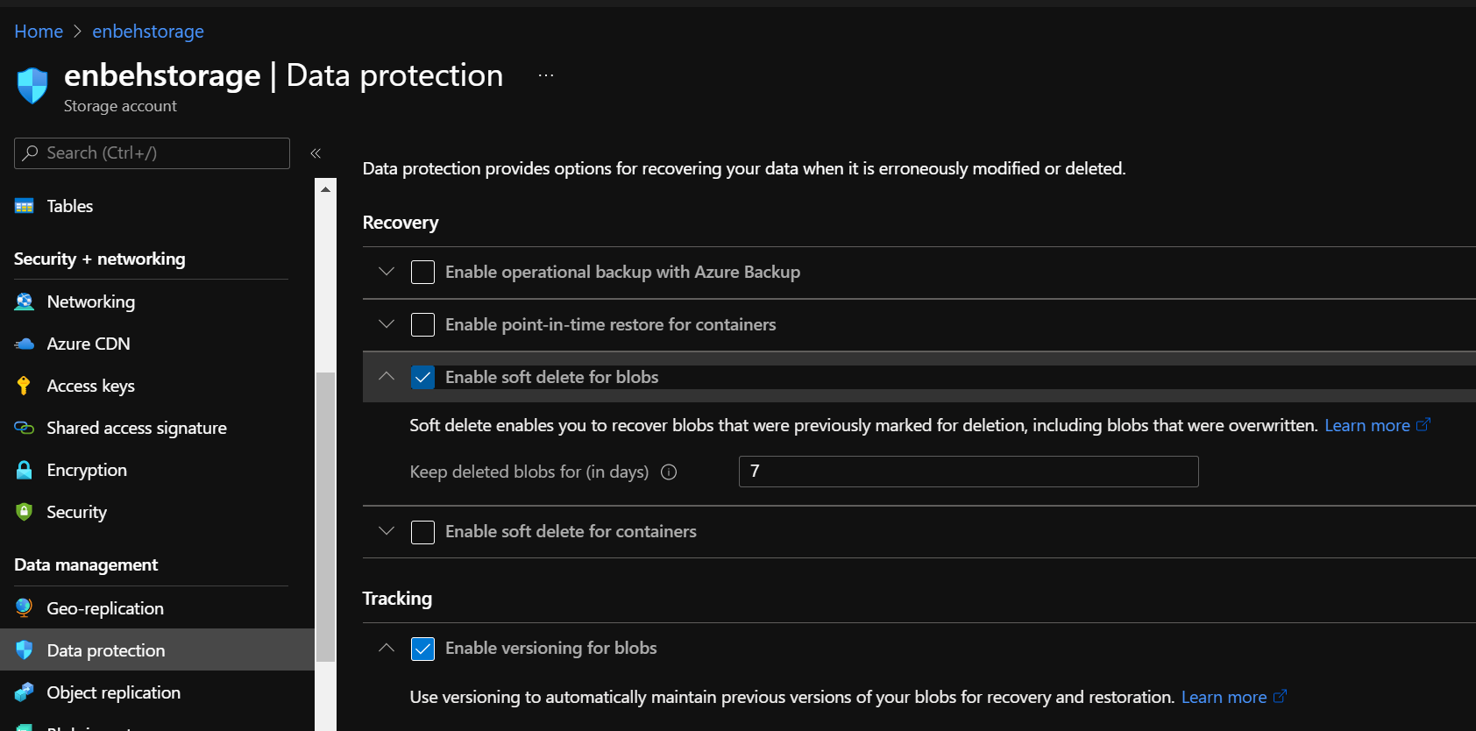

**(you can apply soft delete on blob, containers) for period of time as see 7 days then it will be terminality deleted)**

**2-make sure that make snapshot for the blob and then delete them and then click on show deleted blob and right click on the deleted blob and you can see undelete blob**

